**How to create Dockerfile:-**

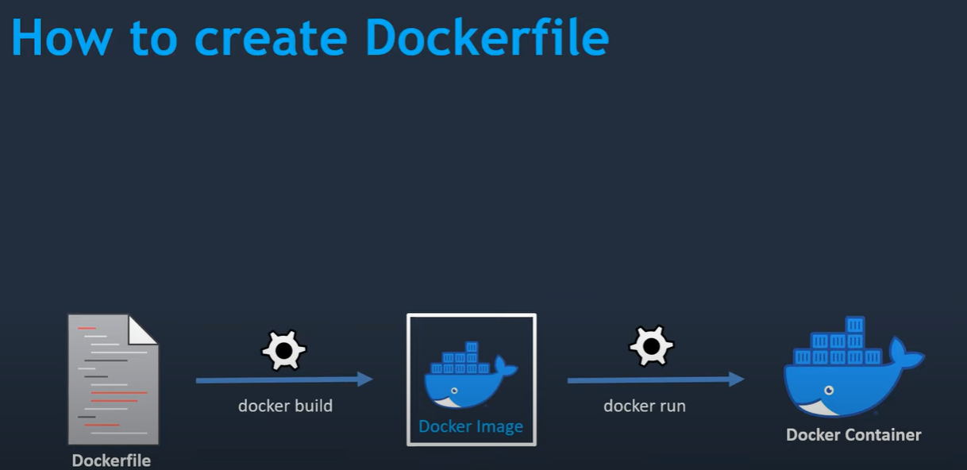

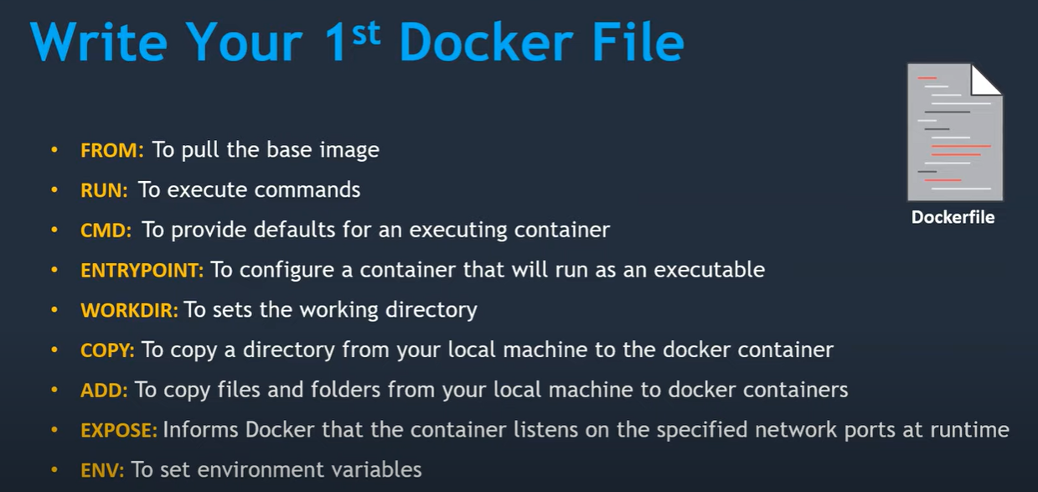

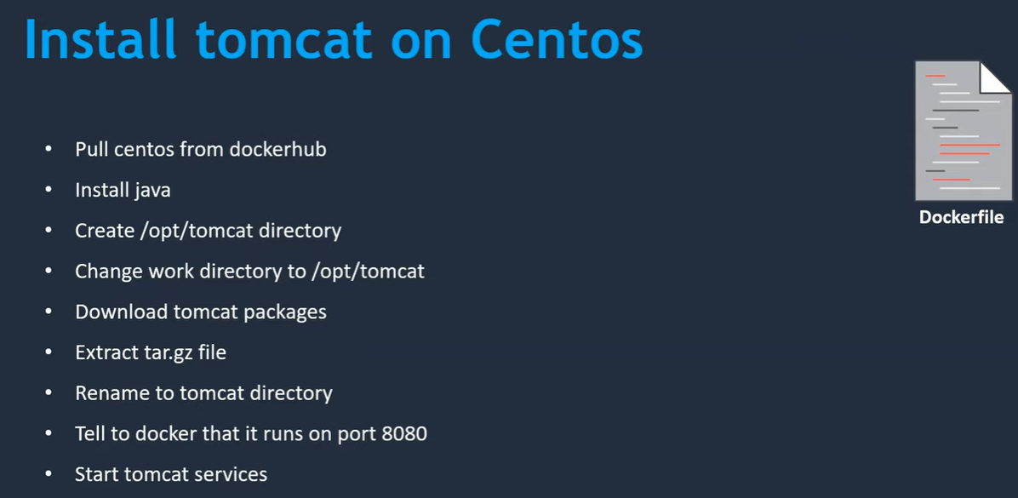

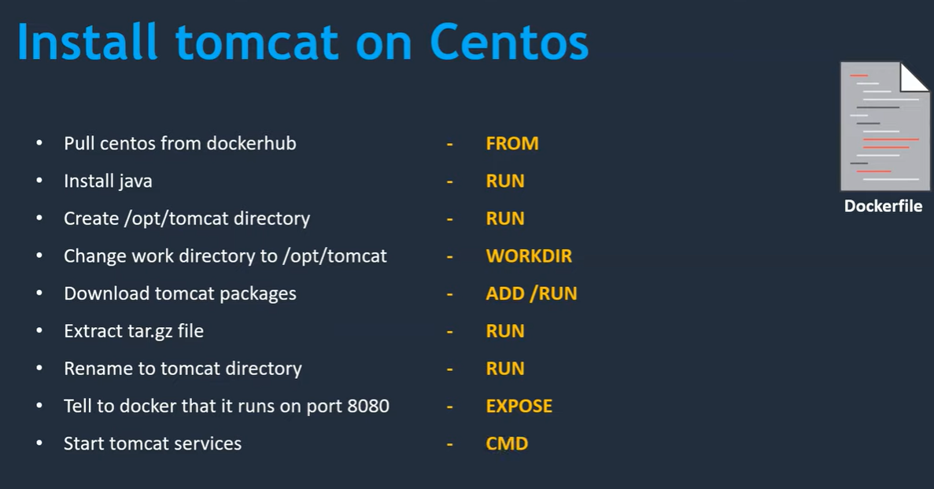

. ex file creation

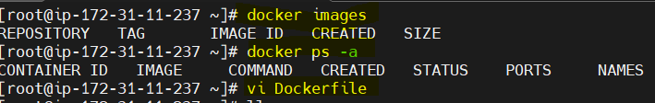

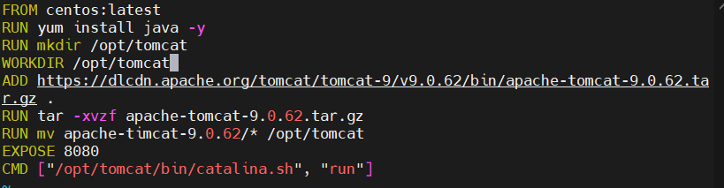

. save

. Create image

. docker build –t mytomcat



. check images

. 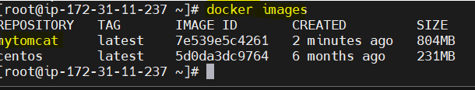

. create container

.docker run –d –name demo-container –p 8082:8080